بخش دوم (MySQL)

1- select \* from persons where firstName like 'a%';

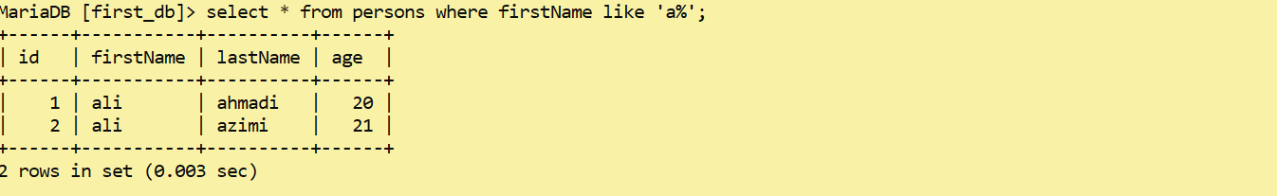

2- select \* from persons where lastName like '%c';

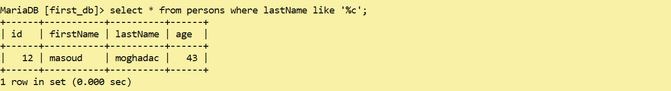

3- select \* from persons where firstName like "%b%" or lastName like "%b%";

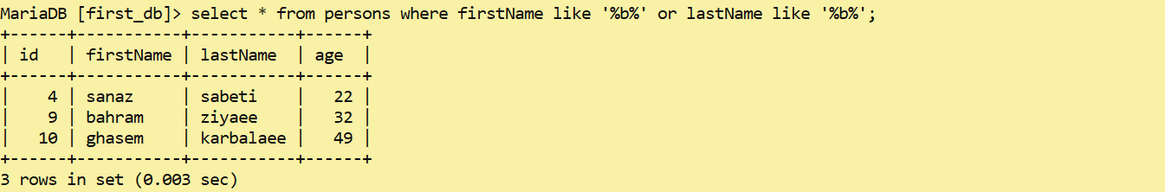

4- select \* from persons where firstName like "%m%" and lastName like "%m%";



5- select \* from persons where (firstName like "%b%" or lastName like "%b%") and age > 18;

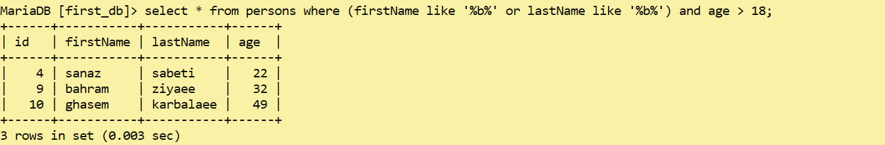

6- select avg(age) from persons;

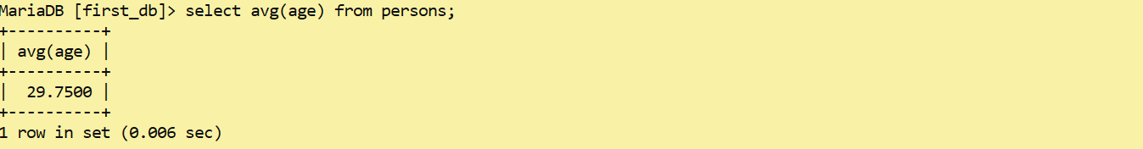

7- select \* from persons where age = (select min(age) from persons);

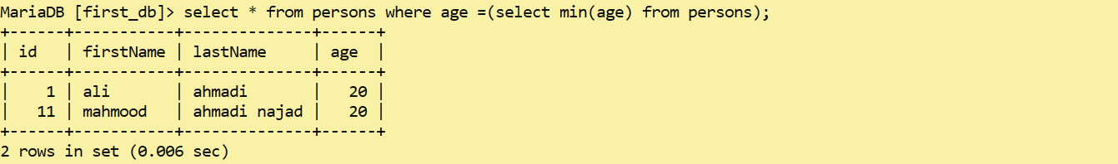

8- select \* from persons where age = (select max(age) from persons);



9- select sum(age) from persons;

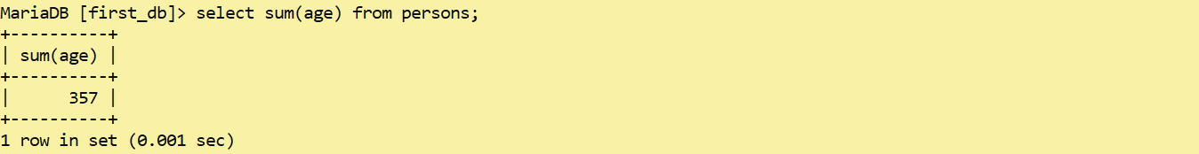

10- select count(age) from persons where age > 18;

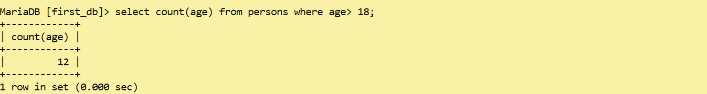

11- select age , count(\*) from persons group by age;

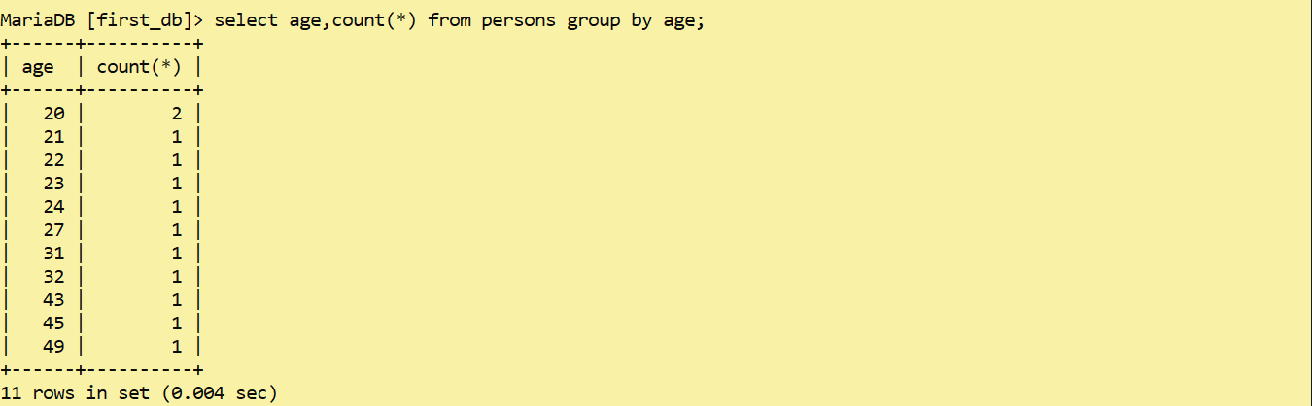

12- select age, city, count(age, city) order by count(age, city) order by count(\*) desc;

